|  |  |
| --- | --- |
|  | **MATHEMATICS METHODS UNIT 3 & 4**  **TEST 5 2019**  **Calculator Free** |

Name: _____________________________

Reading Time: 2 minutes

Total Marks: 18 marks Time Allowed: 18 minutes

Question 1 (4 marks)

A survey of 1000 customers to the Teltale help line was conducted in which the time that each customer spent on hold while waiting for help operator. They are shown in 30 second intervals, with the first interval being from 0 to 30 seconds.

Find

a) P(t < 120 seconds) (1 mark)

b) P(60 ≤ t < 150) (1 mark)

c) P(t > 30 | t < 90) (2 marks)

Question 2 (5 marks)

(a) Let X be a continuous random variable whose probability density function is  for an interval $0<x<c .$ What is the value of the constant $c$ that makes $f(x)$ a valid probability density function? Clearly show all working. (3 marks)

(b) Consider the probability density function $w\left(x\right)=\frac{1}{20}$ where $12≤x≤32$ and $w\left(x\right)=0$ otherwise. Determine the expected value of $w(x)$. (2 marks)

Question 3 (2 marks)

In a Specialist exam, the class achieved an average of 45% with a standard deviation of 15%. The teacher decided to scale the marks so that the mean would be 65% and the standard deviation 12%.

Jason got a raw score of 40%. What would be his scaled score.

Question 4 (7 marks)

The distribution of marks of 150 students in a Semester 2 examination at a local school were found to be normally distributed with a mean  and standard deviation 

Joanne sat this examination and scored 63%.

Note: In a normal distribution, approximately

68% of the values lie within one standard deviation of the mean

95% of the values lie within two standard deviations of the mean

99.7% of the values lie within 3 standard deviations of the mean

(a) How many students scored above Joanne? (2 marks)

The same examination was sat by students in a nearby school. The results of these students were also normally distributed and reflected a higher mean and lower standard deviation than the students of the first school.

(b) On the axes below draw a clearly labelled diagram that demonstrates the relationship between the distribution of scores in the two schools. (2 marks)

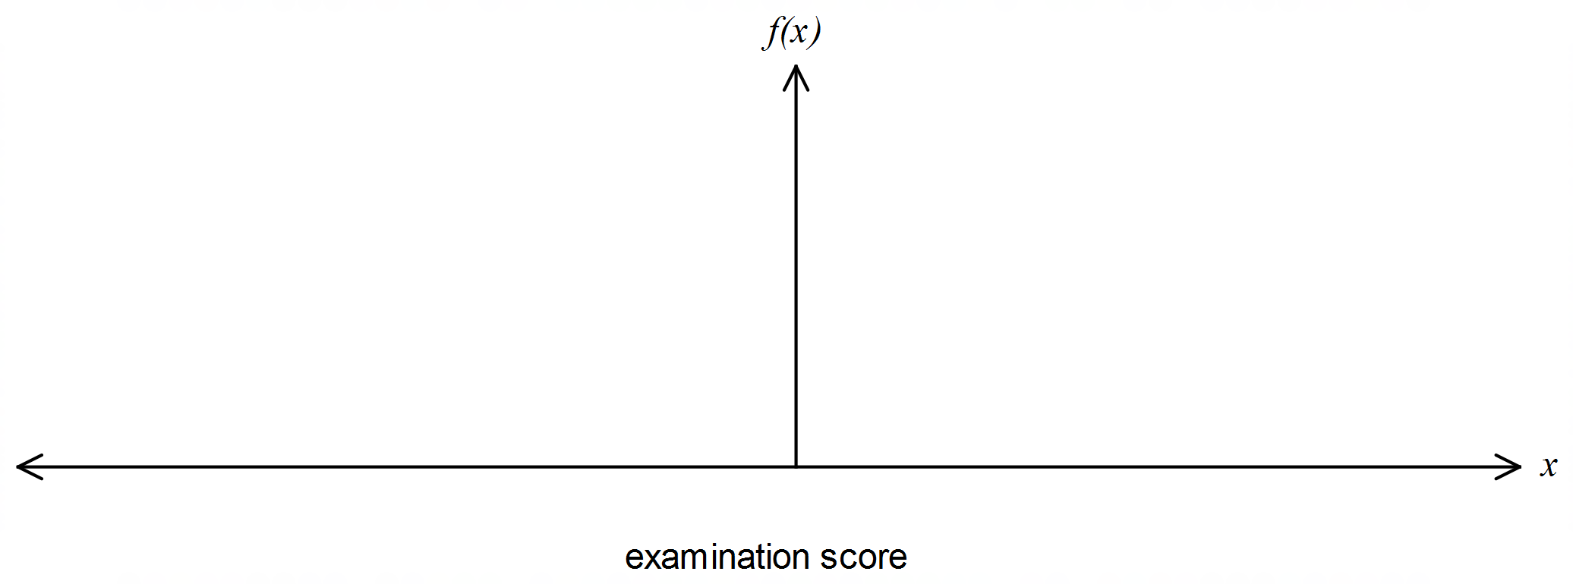

The principal of the first school was not happy with the results of the students and asked that the Mathematics Department scale the scores to ensure that the results reflected a mean of 55% and standard deviation of 6%.

The head of the Mathematics Department applied a linear transformation to the results to obtain *Y* scores for the students. She used the transformation  where *X* represented the original results of the students and *Y*, the scaled scores.

(c) Determine the value of *a* and *b*. (3 marks)

|  |  |
| --- | --- |
|  | **MATHEMATICS METHODS UNIT 3 & 4**  **TEST 5 2019**  **Calculator Assumed** |

Name: _____________________________

Reading Time: 2 minutes

Total Marks: 37 marks Time Allowed: 38 minutes

Question 5 (9 marks)

A bus service departs from a terminus every 30 minutes throughout the day. If a passenger arrives at the terminus at a random time to catch the bus, their waiting time, in minutes, until the next bus departs is a uniformly distributed random variable.

(a) Sketch the graph of the density function of . (2 marks)



(b) What is the probability that a passenger who arrives at the terminus at a random time has to wait no more than 25 minutes for the bus to depart? (1 mark)

(c) Determine . (2 marks)

(d) Determine the value of  for which . (2 marks)

(e) What is the probability that fewer than four passengers, out of a random selection of ten, have to wait at least 25 minutes for the bus to depart?

(2 marks)

Question 6 (8 marks)

The random variable $X$ denotes the number of hours that a business telephone line is in use per nine hour working day.

The probability density function of $X$ is given by $f\left(x\right)=\left\{\begin{matrix}\frac{{\left(x-a\right)}^{2}+b}{k} & 0≤x≤9 \\ 0 & \text{otherwise}\end{matrix}\right.$,

where $a$, $b$ and $k$ are constants.

(a) If $a=15$ and $b=3$, determine the value of $k$. (2 marks)

(b) Let $a=16$, $b=1$ and $k=1260$.

(i) The business is open for work for 308 days per year. On how many of these days can the business expect the phone line to be in use for more than eight hours?

(2 marks)

(ii) Determine, correct to two decimal places, the mean and variance of $X$. (4 marks)

Question 7 (6 marks)

The speeds of 250 vehicles, on a section of freeway undergoing roadworks with a speed limit of 60 kmh-1, had a mean and standard deviation of 56.9 kmh-1 and 3.6 kmh-1 respectively. A summary of the data is shown in the table below.

|  |  |  |  |  |  |
| --- | --- | --- | --- | --- | --- |
| Speed ( kmh-1) |  |  |  |  |  |
| Relative frequency | 0.024 | 0.272 | 0.504 | 0.188 | 0.012 |

(a) Use the table of relative frequencies to estimate the probability that the next vehicle to pass the roadworks

(i) was not exceeding the speed limit. (1 mark)

(ii) had a speed of less than 65 kmh-1, given they were exceeding the speed limit.

(1 mark)

(b) Subsequent tests on the measuring equipment discovered that it had been wrongly calibrated. The correct speed of each vehicle, $v$, could be calculated from the measured speed, $x$, by increasing $x$ by 6% and then adding 1.7.

(i) Calculate the adjusted mean and standard deviation of the vehicle speeds.

(2 marks)

(ii) Determine the correct proportion of vehicles that were speeding. (2 marks)

Question 8 (7 marks)

A hardware store sells stakes, of nominal length 1.8 metres, to be used for supporting newly planted trees. The length, $X$ metres, of the stakes can be modelled by a normal distribution with mean 1.85 and standard deviation $σ$.

(a) If $σ=0.035$, determine

(i) the probability that a randomly chosen stake is shorter than 1.8 metres. (1 mark)

(ii) the probability that a randomly chosen stake is longer than 1.79 m given that it is shorter than 1.8 metres. (2 marks)

(iii) the value of $k$, if the longest 15% of stakes exceed $k$ metres in length. (1 mark)

(b) A large number of stakes were measured and it was found that 97% of them were longer than their nominal length. Show how to use this information to deduce that the value of $σ$ is 0.027 when rounded to three decimal places. (3 marks)

**Question 9 (7 marks)**

An orchardist produces peaches and sells them at the markets. Peaches are categorized into sizes - small, medium and large according to the diameter of the individual fruit.

In 2016, the diameters of the crop of peaches were found to be normally distributed with a mean of 65 mm and a standard deviation of 4.9 mm.

The table below shows the classification and expected profit for individual peaches.

|  |  |  |  |
| --- | --- | --- | --- |
|  | small | medium | large |
| Diameter (*d*) of peach,  in millimetres |  |  |  |
| Expected profit per peach | $0.12 | $0.23 | $0.27 |

(a) Complete the table to show the proportion of peaches of each size in the orchardist’s crop in 2016.

|  |  |  |  |
| --- | --- | --- | --- |
|  | small | medium | large |
| Proportion of peaches |  |  | 0.1538 |

(1 mark)

(b) Determine the expected mean and standard deviation of the orchardist’s profit per

peach for 2016. (3 marks)

The peaches are randomly packaged in polystyrene trays of 25 peaches per tray. The cost of each tray is $0.15.

(c) Ignoring any other costs, determine the expected mean and standard deviation of the profit of a tray of peaches. (3 marks)